Rempstone Village Hall
33 Main Street, Rempstone, LE12 6RH
My Life as a Garden Designer
a talk by
Karen Gimson

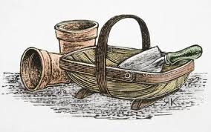

Friday 14 October 2022
Doors open 7.00 p.m.
Ticket - £7.50
(Includes one drink & nibbles)
Licensed Bar available all evening

BOOKING FORM

Name/s: ………………………………No of tickets:…………

Total:……………… (Cheques to Rempstone Village Hall)

For BACS Payment:
Name of Bank | Barclays
 | Rempstone Village Hall
ACC.NO.: | 20756822
SORT CODE: | 205269
REFERENCE: | Surname+RVH eg Smith RVH

Please return your booking form with payment to Rempstone VH.
Email: je.schober@btinternet.com

